Peterborough Drug Strategy Lived Experience Advisory Panel

Panel evaluation

# Preamble

Evaluation and feedback is integral to the function and sustainability of the PDS Lived Experience Advisory Panel (LEAP or ‘the panel’). The panel has been evaluated twice through anonymous surveys. The evaluations aim to understand how panelists feel about the panel structure, their satisfaction as an independent consultant, how they feel the panel is impacting the community, and how they feel the panel has impacted their personal and professional lives.

Each survey was sent to panelists which included several multiple choice and written answers. The panelists were given a week to complete each survey and were paid (based on PDS’ lived experience compensation policy) for the time it took them to complete the survey. Once the evaluations were completed and synthesized, PDS staff presented the results to the panel to ensure that the results were being interpreted correctly and to initiate discussion. The panel brainstormed about how some pieces could be improved and conversed about the impact and future.

# Panel process

When asked about how they felt the panel process was going, panelists highlighted that they felt it was going ‘pretty well, with some room for improvement’. Panelists reflected on the work, with one person explaining “The idea for this panel is wonderful - a real new big step for Peterborough, and a real potential asset to the community” (Panelist, 2019) and another describing “I think we have a lot of work to do in the department of feeling fulfilled”. It was clear that there was high satisfaction but that panelists saw growth opportunities for the panel. The panelists were asked to comment on the strengths and challenges of the panel process.

## Strengths

Three main strengths have been identified by panelists as they key to the panel’s success:

1. **Contribution and panel style: feeling hard and valuable as lived experience experts, appreciating that that all voices on the panel are elevated.**

* “I always feel heard, and I think we work well as a group, checking in on quieter members as we go. I feel like what I say is of value and I feel heard and supported.” (Panelist, 2022)
* “I am really impressed with the group dynamics and the visible effort being made to include everyone's voice.” (Panelist, 2019)

1. **Presentations: value in the variety of presentations, the discussions that are had, etc. Important to have background readings and paid time to research the topic beforehand.**

* “I love the presentations and our model of providing feedback. I also really appreciate the prep work beforehand.” (Panelist, 2022)
* “When I think of the sessions in which we made the greatest impact they involved projects that were in the planning stage, and where changes can be made. As a panel, I feel that the camaraderie we have built allows us to be open with each other and with the presenters.” (Panelist, 2019)

1. **People: the variety of perspectives on the panel (of people who have lived experience) coming together. Appreciation of group dynamic and support for one another.**

* “The group dynamics are wonderful and my favourite part of the panel…” (Panelist, 2022)
* “I really love that there is a diverse group of experiences. I think it adds a great variety of perspectives.” (Panelist, 2022)

1. **Training: the capacity-building of the panel, empowering (and paying) panel members to get involved in training/courses etc.**

* **“**The building of panelist capacity is also something I value very much.” (Panelist, 2022)
* **“**I appreciate the additional training and education I am receiving as being part of the panel, all of which has cross-sectional value in my other work…” (Panelist, 2019)

## Challenges

The panel consistently strives for growth and to better its practices. A handful of challenges were highlighted, which the group has actively worked to address.

1. **Diversity in demographics: while both panel evaluations highlighted contentment with the variety of people on the panel, several raised the issue of diversity (especially regarding equity-deserving groups) on the panel.**

* “… more current experience and a diversity of representation on the panel would strengthen what we have to say to presenters” (Panelist, 2022)

1. **Unity of group purpose/fulfillment of panel: one of the most significant critiques of the panel structure is that panelists can struggle to discern the group purpose leading to a struggle of fulfillment for the panel. As seen in figure 4 and 5, there is not consensus on panel impacts, thus indicating uneven perception of group impact.**

* Lack of clear, unified, and continuing understanding of our purpose can be a challenge. We seem to need fairly frequent reigning in or reminders of what we actually are here for. However, I do also see the value in panelists continuing to push the envelope and not settling for being confined to a tick box of consultation” (Panelist, 2022)
* “A possible continued challenge for the panel could be maintaining a momentum and having the ability to see achievement through initiatives brought forward and their implementation within programs.” (Panelist, 2019)
* “I think we’re really struggling to feel fulfilled as a group. I also sense a bit of a divide in the group, between those who feel content with the work we’re doing, and those who feel like we’re not making changes or being heard.” (Panelist, 2022)

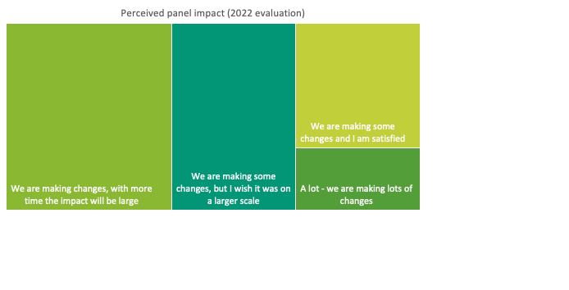

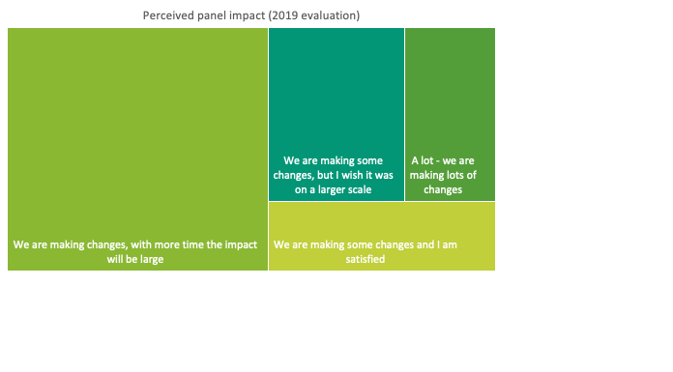

1. **Attendance: a more recent challenge of the panel is attendance. As will be explored later, the panel experience has allowed panelists the opportunity to gain employment. However, with this, it has become more challenging for consistent attendance due to work schedules.**
2. **Funding model:** **a consistent challenge with the panel is its reliance on project-based, limited funding. Many panelists have expressed that this can limit what the panel can do, despite its capabilities.**

# Panel impact

## Professional impact on panel members

Panelists emphasized that their involvement in the panel has been impactful for them in three main ways:

1. **Systems awareness: gaining knowledge of the system beyond just addictions, but also the issues that intersect (and the bigger picture). The panel has also helped them in understanding the resources that are available.**

* “I am slowly beginning to understand the system better. I am also learning more about homelessness and its connection to mental health and addiction.” (Panelist, 2022)
* “I am also now more aware of the agencies, resources and challenges accessing such, which will help me direct community members better on connecting to supports/resources” (Panelist, 2022)

1. **Careers: several panelists highlighted that involvement in the panel has had a direct impact on their careers (either gaining employment in the field of addictions/mental health or helping panelists gain confidence in a broader way).**

* “A huge impact professionally. I have gone on to find work with [other organizations] sharing lived experience as a consultant.” (Panelist, 2022)

*“The panel paved the way for my current career. It was also my introduction to systems work, which I was previously completely unaware of.” (Panelist, 2022)*

1. **Opportunities: outside of specific careers, the panelists highlighted that their work on the panel has paved opportunities for them to use their lived experience consultation power in other ways.**

* “I already run a support group and this panel has definitely influenced different paths our support group has taken with our volunteering in the community.” (Panelist, 2019)
* **“**I’m much more confident than I was before, and that has led me to seek more employment elsewhere.” (Panelist, 2022)

## Personal impact on panel members

Panelists underscored several ways that the panel has impacted their personal lives, including:

1. **Building connections and fostering growth of relationships between panel members:**

* “I have begun to cultivate personal connections with members.” (Panelist, 2022)
* “Working within a large group with different views helps me to expand my own world view, and helps me to develop more empathy and compassion, not just for the marginalized people, but also the organizations trying to help.” (Panelist, 2019)

1. **Useful in personal journey:**

* “The panel augmented my personal recovery in many ways, helped me form a healthy identity around my lived experience, and enabled me to build relationships with other panel members that I wouldn't otherwise have met.” (Panelist, 2022)
* “It adds to purpose in my life and my career.” (Panelist, 2022)
* “It’s help me stay sober. It’s sort of gives me a sense of belonging to the community.” (Panelist, 2022)
* “Makes me accountable to show up to something.” (Panelist, 2022)

1. **Developing intangible skills/traits like confidence:**

* “I feel that I am gaining confidence having my opinions heard, and learning a lot more about what resources or community has.” (Panelist, 2019)
* “I feel my confidence has soared throughout my time with the panel, my knowledge of my own journey through addiction and recovery… It has got me unstuck from my just surviving life in recovery to living in recovery knowing I'm doing it right, for me and that's what matters.” (Panelist, 2022)

*“Being seen, being heard, being valued. It is and has been life changing, lifesaving, and life affirming. The opposite of addiction is not sobriety - it is connection, respect, friendship, creativity, self-worth.” (Panelist, 2022)*

## The importance of the panel in the community

1. **Legitimizing the voices of people who have lived experience: using people with lived experience as paid professionals, demonstrating the value of incorporating these perspectives into program/policy/initiative design, implementation, and evaluation.**

* “This panel gives a voice to those with lived experience with substance use, which is huge, because consultation with those with lived experience is lacking in our social services system.” (Panelist, 2022)
* “It gives a voice to those who are often left unheard, undervalued, and dehumanized.” (Panelist, 2022)
* “You cannot build a community that is wholesome, drug -free, drug - reduced, drug - safe for users, without hearing from the people who live/have lived there! You just can't!” (Panelist, 2019)

1. **Bettering services for people who use drugs: by consulting people who have lived experience, the panel is able to share insights to agencies that they may not have considered. Thus, the panel offers a unique service that allows agencies to design programs that actually meet people’s needs.**

* “Peterborough had gotten so many more resources and clinics and it's moving forward so I have to believe the stigma is slowing down a little and opening society's eyes to the huge problem we have. These people are someone's kids and parents and need help.” (Panelist, 2022)
* “The importance of this panel for our community is to save lives and to reduce harm within the community. To find solutions.” (Panelist, 2019)
* “This is what our community needs. PEOPLE ARE DYING. I want to scream it every day as it seems as though it is being ignored” (Panelist, 2022)
* “This panel is hopefully helping to shape the resources available to drug users and families in our community.” (Panelist, 2019)

# Conclusions

It is clear the PDS’ Lived Experience Advisory Panel is a necessary addition to the community and fills a gap in current services. The purpose of evaluating the panel from the perspective of panelists is to understand their perception of the strengths and challenges of the current format, as well as the impacts of the work on their lives and the community. The panel has room to grow and does face several limitations, but it has a strong foundation to flourish upon.